長庚大學資訊工程學系 一百零六學年度上學期計算機圖學課程小考試題II
上課班級: 三年甲班 授課老師: 林俊淵
受測範圍: Slides 7~8

- Please write an OpenGL program to draw the picture according to the following steps. (50 point)
Step 1: please set and draw an original object as the Figure 1.a (red color).
- object: {50.0, 300.0}, {150.0, 300.0}, {200.0, 350.0}, {100.0, 400.0}, {0.0, 350}
- windows size 600x600
- projection plane (0, 600, 0, 600)
Step 2: find the centriod point PA for the object (Figure 1.a).
Step 3: use the centroid point PA as a pivot point to do the rotation with angle -180∘.
Step 4: do the translation with tx= 200, ty= -250.
Step 5: find the centroid point PB for the object after step 4.
Step 6: use the centroid point PB as a fixed point to do the scaling with sx=3.0, sy=1.5.
Step 7: use the centroid point PB as a pivot point to do the rotation with angle -90∘.
Step 8: use the centroid point PB as a fixed point to do the scaling with sx=0.6, sy=0.3.
Step 9: do the translation with tx= 250, ty= 0.
Step 10: draw the object after Step 9 with blue color (projection plane (0, 600, -600, 600))

- Please write an OpenGL program to draw the picture according to the following steps. (50 point)
Step 1: please set and draw an original object as the Figure 2.a.
(green (90∘~270∘) and red (270∘~90∘))
- object: Center {100, 100}, Radius: 100
- windows size 400 x 400
- projection plane (-200, 400, -200, 400)
Step 2: use the point (0.0, 0.0) as a pivot point to do the rotation with angle 90∘.
Step 3: do the translation with tx= 500, ty= 500.
Step 4: find the centroid point PA for the object after step 3.
Step 5: use the centroid point PA as a fixed point to do the scaling with sx=sy=4.
Step 6: use the centroid point PA as a pivot point to do the rotation with angle 60∘.
Step 7: do the translation with tx= 200, ty= 0.
Step 8: draw the object after Step 8 (projection plane (0, 1000, 0, 1000)

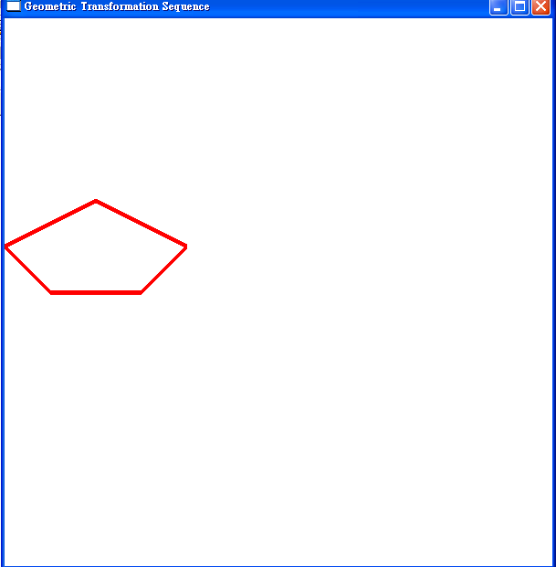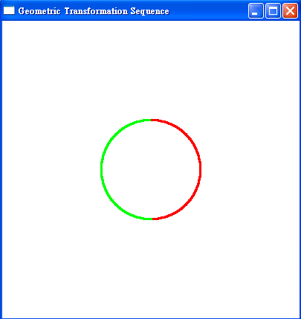
Figure 1.a Figure 2.a

作答完請舉手請老師過去批改.

